

SHANGHAI JIAO TONG UNIVERSITY

**概率论和数理统计**

PROBABILITY THEORY AND MATHEMATICAL STATISTICS

**大作业**

MAJOR ASSINGMENT

**基于计算机模拟实验的伯努利**

**大数定律适用性分析**

20xx年xx月

学生姓名:

学生学号:

专 业:

教 师:

**摘要**

伯努利大数定律给出了一个普遍结论：大量的重复试验会使结果趋于稳定。具体而言，当 $N$ 足够大时，随机事件A发生的频率 $N_{A}/N$ 依概率收敛于A在一次试验中发生的概率 $p$。本作业将先对伯努利大数定律进行基本的理解与阐释，并通过计算机模拟实验先进行上述定律的验证，再通过不同的 $N$ 取值并计算对给定 $ε$ 的概率，来确定一个最经济并最适合的用于估算的事件发生概率的 $N$ 的取值，最后给出了一些简便的大数定律在数理统计、管理决策等方面的应用，为某些生产活动做出指导，当然最主要是为了完成我的大作业。

在第一章会给出基本概念和理解，以及实际生活中无法解决的问题；在第二章会先进行验证，然后给出一个可以实现的近似估计，来解决实际生活中无法达到正无穷的问题；在第三章，会以第二章给出的估计条件为基础，来为不同场景下n的取值的适用性做出分析；在第四章，会给出一些使用的例子。

**关键词**  伯努利大数定律；独立重复试验；适用范围估计

目录

一、 伯努利大数定律 4

二、 用计算机模拟实验进行验证 5

1、方法 5

2、实验结果 5

3、解决无穷的方法 7

三、 在实际问题中的适用性分析 8

1、方法 8

2、实验结果 8

3、实际使用适用性 10

四、 伯努利大数定律的应用 11

# 伯努利大数定律

伯努利大数定律是概率论中的一个重要定律，它描述了随机事件重复独立进行多次时，事件出现的频率会依概率收敛于该事件发生的概率的规律。具体来说，伯努利大数定律可以简述为：在一系列独立重复的随机试验中，如果事件A的概率为p，则当试验次数n趋近于无穷大时，事件A发生的频率n_A/n趋近于p。

用符号表述为:

$$\begin{aligned}∀ε>0 , \lim_{n→+∞}{P\left(\left|\frac{n_{A }}{n}-p\right|≥ε\right)=0} or \lim_{n→+∞}{P\left(\left|\frac{n_{A }}{n}-p\right|<ε\right)=1}\#\left(\text{1-1}\right)\end{aligned}$$

伯努利大数定律是概率论中非常基础且广泛应用的一个定律，它在科学研究，如在统计学、保险学、金融学、物理学、生命科学等领域都有广泛的应用。

Bernoulli早在 1713 年就已经发现该定理的结论,他观察到当大量重复某一试验时，随着试验次数越来越多,某个随机事件的频率会稳定于该随机事件的概率。为了纪念他所做的贡献，该结果称为Bernoulli大数定律.而且他成功地通过数学语言将现实生活中这种现象表示出来，赋予其确切的数学含义，让人们对于这一类问题有了新的认识和深刻的理解，为后来研究大数定律问题奠定了基础除Bernoulli之外，还有很多数学家为大数定律的发展做出了重要的贡献，像Laplace(拉普拉斯)、Lyapunov(李雅普诺夫)、Lindeberg(林德伯格)、Feller(费勒)、Chebyshev(切比雪夫)、Khintchine(辛钦)等他们对于大数定律乃至概率论的进步所起的作用都是不可估量的。[1]

在实际生产中，n趋于正无穷是不可能做到的，因此，需要确定可以实际验证的个数，来确定一个伯努利大数定律的估计，来使得实际使用伯努利大数定律时有足够的准确性。

# 用计算机模拟实验进行验证

## 方法

1. 给定一次随机试验中事件A发生的概率（即成功概率）
2. 用计算机模拟100000次随机试验，统计成功次数
3. 代入公式(1-1)验证
4. 选取另外9个成功概率，重复1-3

## 实验结果

下面的表格给出了10组不同成功概率在1000000次试验中的成功频率：

|  |  |  |  |  |  |
| --- | --- | --- | --- | --- | --- |
| 成功概率 | 试验次数 | 成功次数 | 成功频率 | 绝对误差 | $$u_{rx}$$ |
| 0.05 | 1000000 | 49944 | 0.049944 | -0.00006 | 0.11% |
| 0.15 | 1000000 | 149884 | 0.149884 | -0.000116 | 0.08% |
| 0.25 | 1000000 | 249551 | 0.249551 | -0.000449 | 0.18% |
| 0.35 | 1000000 | 349835 | 0.349835 | -0.000165 | 0.05% |
| 0.45 | 1000000 | 449896 | 0.449896 | -0.000104 | 0.02% |
| 0.55 | 1000000 | 550331 | 0.550331 | 0.000331 | -0.06% |
| 0.65 | 1000000 | 649927 | 0.649927 | -7.3E-05 | 0.01% |
| 0.75 | 1000000 | 749522 | 0.749522 | -0.000478 | 0.06% |
| 0.85 | 1000000 | 849901 | 0.849901 | -9.9E-05 | 0.01% |
| 0.95 | 1000000 | 949874 | 0.949874 | -0.000126 | 0.01% |

表格 1 2-1

表格中，成功频率计算公式为

$$\begin{aligned}\frac{n_{A}}{n}\#\left(\text{2-1}\right)\end{aligned}$$

绝对误差计算公式为

$$\begin{aligned}\frac{n_{A}}{n}-p\#\left(\text{2-2}\right)\end{aligned}$$

定义相对误差为 $u_{rx}$， $u_{rx}$ 计算公式为

$$\begin{aligned}\left(1-\frac{\frac{n_{A}}{n}}{p}\right)×100\% \#\left(\text{2-3}\right)\end{aligned}$$

不难发现满足式(1-1)的 $ε$ 的下限即为绝对误差的绝对值，即

$$\begin{aligned}ε_{L}=\left|\frac{n_{A}}{n}-p\right|\#\left(\text{2-4}\right)\end{aligned}$$

下面给出 $ε$ 的下限随成功概率的变化曲线：

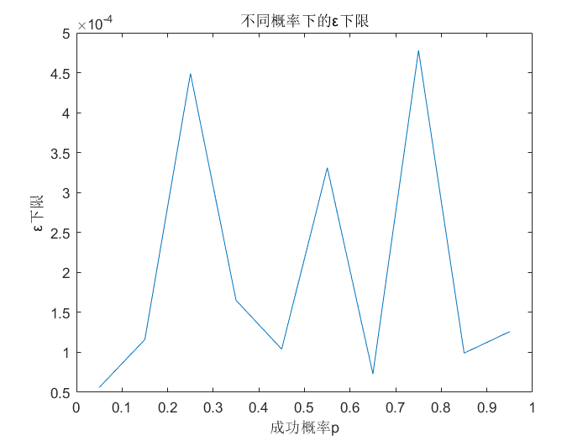

图表 1 2-1

在后续实验中，又做了100组不同概率，每组1000000个，结果如图：

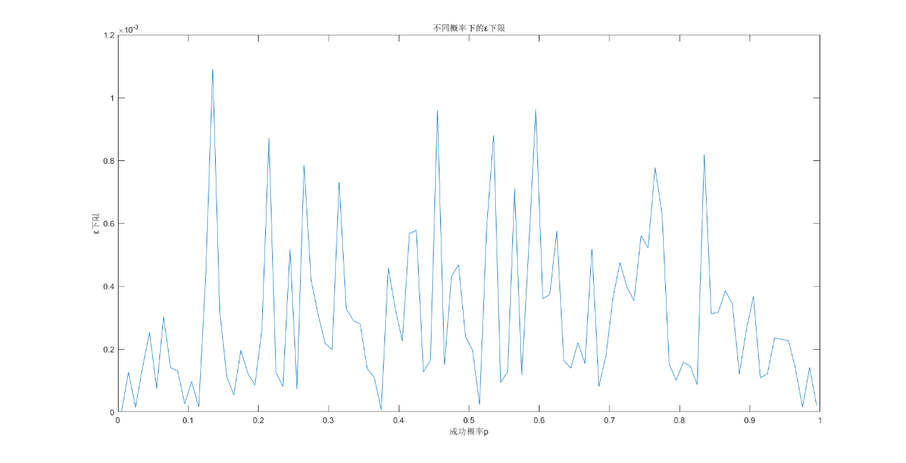

图表 2 2-2

不难发现对于不同的p，ε的取值普遍很小。

如果取 $ε_{L}=1.2×{10}^{-3}$ (实际上是远远小于这个值的)，那么根据式（2-4），可以得到

$$\left|\frac{n_{A}}{n}-p\right|≤1.2×{10}^{-3}$$

其中 $u_{rx}$ 的最大值不超过1%（0.81%，当p=0.135时取到），可以认为在一般情况下满足式（1-1）。

## 3、解决无穷的方法

在一般的应用中， $u_{rx}$ 小于1%已经是相当准确的量（当然，在一些需要精密值的地方如科学计算、高水平制造等场景仍不算准确）。

若认为

$$ε\sim U\left(0,p\right)$$

则

$$F_{ε}\left(x\right)=\left\{\begin{aligned}&0 x<0 \\ &\frac{x}{p} 0≤x<p \\ &1 x≥p\end{aligned}\right.$$

且满足

$$P\left(\left|\frac{n_{A }}{n}-p\right|≥ε\right)≤1\%$$

为符合实际应用中的大数定律，有

$$F_{ε}\left(\left|\frac{n_{A }}{n}-p\right|\right)≤1\%$$

可以得到

$$\begin{aligned}\left|\frac{n_{A }}{n}-p\right|≤\frac{p}{100} ⇒\left|1-\frac{n_{A }}{np}\right|≤1\%\#\left(\text{2-5}\right)\end{aligned}$$

即 $u_{rx}$ 小于1%，就是上文得到的结果。

由此，成功用计算机模拟实验验证了伯努利大数定律。

第三章将以 $u_{rx}$ 为基础，做出n的取值与适用性的关系。

# 在实际问题中的适用性分析

## 方法

1. 基于 $u_{rx}$ 这一概念
2. 由于结论将对不同p取值有普遍性，取p=0.5作为分析对象
3. 做1000000组试验，记录下每次试验结果
4. 依次在全部试验中随机抽取10，100，1000，10000，100000，1000000次的结果，进行与表1 2-1类似的分析，得到 $u_{rx}$ 与试验次数n的关系
5. 给定确定的 $u_{rx}$，作为限定条件，依次为1%，2%，5%，10%，利用4得到的曲线，计算得到分别得到这些误差的试验次数，给出不同要求下所需的试验次数

## 实验结果

下面给出给定n，计算 $u_{rx}$ 的试验结果：

|  |  |  |  |  |
| --- | --- | --- | --- | --- |
| 成功概率 | 0.5 |  |  |  |
| n | 成功次数 | 成功频率 | 绝对误差 | $$u_{rx}$$ |
| 10 | 4 | 0.400000 | -0.100000 | 20.00% |
| 100 | 45 | 0.450000 | -0.050000 | 10.00% |
| 1000 | 511 | 0.511000 | 0.011000 | -2.20% |
| 10000 | 5024 | 0.502400 | 0.002400 | -0.48% |
| 100000 | 50171 | 0.501710 | 0.001710 | -0.34% |
| 1000000 | 500493 | 0.500493 | 0.000493 | -0.10% |

表格 2 3-1

观察表格不难发现，当n较小时 $u_{rx}$ 非常大，偏离量很大；当n取1000时， $u_{rx}$ 小了一个数量级；n再变大， $u_{rx}$ 变小。这个过程符合伯努利大数定律的描述（见第一章），也算一种验证。

做出波特图：

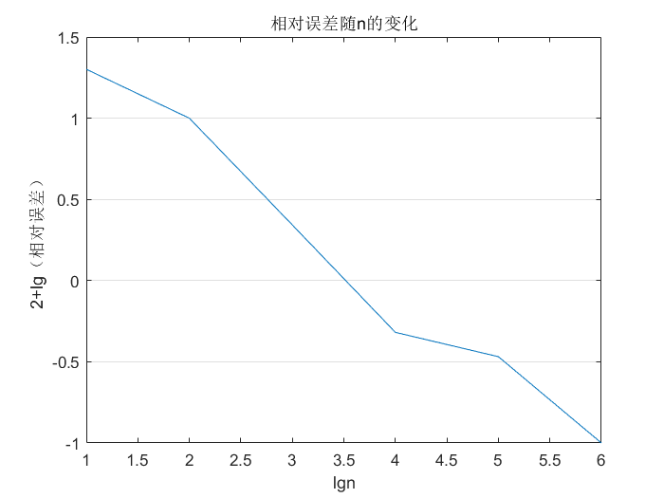

图表 3 3-1

图中纵坐标为0的点表示 $u_{rx}$ 为1%，就是上文中提出的近似估计点。

可以发现，当n取3500左右时，可以将 $u_{rx}$ 降到1%以内，即

$$\begin{aligned}n≥3500⇒P\left(\left|\frac{n_{A }}{n}-p\right|≥ε\right)≤1\%\#\left(3-1\right)\end{aligned}$$

由此，找到了第一个近似估计点。

在 $n≤3500$ 时继续细分，得到更准确的曲线，最终得到：

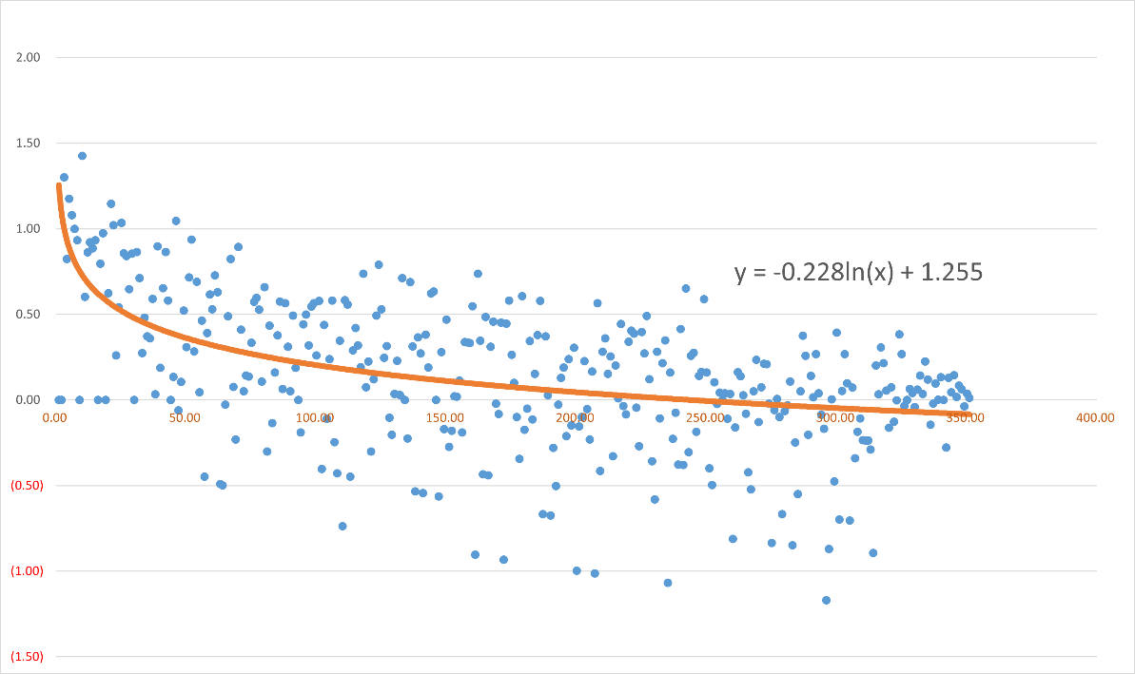

最终选择对数拟合，得到 $lg⁡(100u_{rx})$ 与 $100lg⁡(n)$ 的关系为：

$$\lg\left(100u_{rx}\right)=-0.228\ln\left(100lg\left(n\right)\right)+1.255$$

$$\begin{aligned}∴u_{rx}={10}^{-0.228\ln\left(\lg{n}\right)-1.795} , n={10}^{e^{-\left(7.87+4.39\lg{u_{rx}}\right)}}\#\left(3-2\right)\end{aligned}$$

观察曲线，发现满足伯努利大数定律所描述的“随n增大趋于稳定”。不仅如此，当n变大时，散点的分布也更加集中，即 $u_{rx}$ 的样本方差变小，进一步拓展了“稳定”的含义：不仅是频率稳定在概率附近，也有每次观测的方差变小之意。

对公式的解读：

1. 选择对数拟合的原因：

在n比较小时（n<1000000），当n增大时 $u_{rx}$ 变小很快；但是，当想要更精准的结果是，所耗费的n应当是指数级上升的，这一点从表格2 3-1 也能看出；且在仿真时，选择n为1000000所消耗时间远远大于n为100000时所耗时间的十倍。

1. 公式的适用范围：

观察散点可以知道，当n比较小时，散点分布很分散，因此拟合结果并不靠谱，只有当n>100时结果才能较好符合。

## 3、实际使用适用性

根据式（3-2），得到下表：

|  |  |
| --- | --- |
| 相对误差 | n |
| 0.10% | 2.1717E+200 |
| 0.20% | 2.72684E+53 |
| 0.30% | 4.63761E+24 |
| 0.40% | 1.78997E+14 |
| 0.50% | 2060764089 |
| 0.60% | 3795061.089 |
| 0.70% | 80139.21107 |
| 0.80% | 6333.578247 |
| 0.90% | 1088.969671 |
| 1.00% | 305.0159379 |

表格 3 3-2

根据该表，在实际使用中，需要统计300个左右数据，才能做到经济又准确。

# 伯努利大数定律的应用

实例1：某电灯生产线需要估计产品合格率，要如何安排寿命测试？

解答1：电灯的寿命并不需要十分准确的取值，取 $u_{rx}=1\%$，查表得安排300个进行测试，最为经济。

实例2：抽样统计某高校学生近视率，统计员只有一位且检查明天就到期，如何才能完成任务？

解答2：学生近视率不需要非常准确的数值，取 $u_{rx}=1\%$，查表得统计300个学生才能完成任务。

实例3：现需要估计某精密仪器某个零件的使用寿命，要如何安排测试？

解答3：由于仪器要求紧密，故零件的寿命要求也会更高，取 $u_{rx}=0.8\%$，查表得需要统计6000个零件的寿命才能确定。

正文完。

**参考文献**

[1]卫淑之.熊德文.皮玲.大学数学 概率论与数理统计——基于案例分析[M].北京：高等教育出版社，2020.

[2]拉穷.论独立随机序列的大数定律与中心极限定理及其应用[D].四川：西南交通大学数学科学院，2007.

**附录**

# 一、程序

## 1、验证所用程序

s = RandStream('mt19937ar','Seed','shuffle');

events = {'A','~A'};

total = 1000000; %总试验次数

step = 0.01; %概率步长

start = 0.005; %起始概率

cnt = 0; %用于计数

rst = []; %存放各次结果

j = 0; %步长计数

psb = start:step:1;

while start+j*step<1

cnt = 0;

for i=1:total

result = randsample(s,events,1,true,[start+j*step 1-start-j*step]);

if strcmp(result,'A')

cnt = cnt + 1;

end

end

rst = [rst cnt];

j = j + 1;

end

varepsilon = abs(rst/total-psb);

plot(psb,varepsilon);

title("不同概率下的ε下限");

xlabel("成功概率p");

ylabel("ε下限");

## 寻找n与 $u_{rx}$ 关系所用程序

s = RandStream('mt19937ar','Seed','shuffle');

events = {'A','~A'};

total = 1000000; %总试验次数

times = 10; %单次取的结果个数

rst = []; %记录试验结果，1表示A发生

allrst = []; %记录给定n的成功次数

p = [];

for i=1:total

result = randsample(s,events,1,true,[0.5 0.5]);

if strcmp(result,'A')

rst = [rst 1];

else rst = [rst 0];

end

end %生成全部结果

j = 1;

while times*j<=3500 %随机取n组不重复

choose = randperm(3500,times*j);

cnt = 0;

for i=1:times*j

if rst(choose(i))==1

cnt = cnt + 1;

end

end

allrst = [allrst cnt];

p = [p 1-cnt/times/j*2];

j = j + 1;

end

x = 10:10:3500;

z = log10(100*p);

plot(log10(x),z);

title("相对误差随n的变化");

xlabel("lgn");

ylabel("2+lg（相对误差）");

# 二、正文中未出现的完整数据

## 验证过程中的100组不同成功概率

|  |  |  |  |  |  |
| --- | --- | --- | --- | --- | --- |
| 成功概率 | 试验次数 | 成功次数 | 成功频率 | 绝对误差 | 相对误差 |
| 0.005 | 1000000 | 5001 | 0.005001 | 1E-06 | -0.02% |
| 0.015 | 1000000 | 15127 | 0.015127 | 0.000127 | -0.85% |
| 0.025 | 1000000 | 25014 | 0.025014 | 1.4E-05 | -0.06% |
| 0.035 | 1000000 | 34859 | 0.034859 | -0.00014 | 0.40% |
| 0.045 | 1000000 | 44746 | 0.044746 | -0.00025 | 0.56% |
| 0.055 | 1000000 | 54926 | 0.054926 | -7.4E-05 | 0.13% |
| 0.065 | 1000000 | 65302 | 0.065302 | 0.000302 | -0.46% |
| 0.075 | 1000000 | 74860 | 0.07486 | -0.00014 | 0.19% |
| 0.085 | 1000000 | 85131 | 0.085131 | 0.000131 | -0.15% |
| 0.095 | 1000000 | 95026 | 0.095026 | 2.6E-05 | -0.03% |
| 0.105 | 1000000 | 104904 | 0.104904 | -9.6E-05 | 0.09% |
| 0.115 | 1000000 | 114984 | 0.114984 | -1.6E-05 | 0.01% |
| 0.125 | 1000000 | 124566 | 0.124566 | -0.00043 | 0.35% |
| 0.135 | 1000000 | 133910 | 0.13391 | -0.00109 | 0.81% |
| 0.145 | 1000000 | 145318 | 0.145318 | 0.000318 | -0.22% |
| 0.155 | 1000000 | 155112 | 0.155112 | 0.000112 | -0.07% |
| 0.165 | 1000000 | 165054 | 0.165054 | 5.4E-05 | -0.03% |
| 0.175 | 1000000 | 174804 | 0.174804 | -0.0002 | 0.11% |
| 0.185 | 1000000 | 184877 | 0.184877 | -0.00012 | 0.07% |
| 0.195 | 1000000 | 195085 | 0.195085 | 8.5E-05 | -0.04% |
| 0.205 | 1000000 | 205262 | 0.205262 | 0.000262 | -0.13% |
| 0.215 | 1000000 | 214128 | 0.214128 | -0.00087 | 0.41% |
| 0.225 | 1000000 | 224874 | 0.224874 | -0.00013 | 0.06% |
| 0.235 | 1000000 | 234920 | 0.23492 | -8E-05 | 0.03% |
| 0.245 | 1000000 | 244484 | 0.244484 | -0.00052 | 0.21% |
| 0.255 | 1000000 | 254927 | 0.254927 | -7.3E-05 | 0.03% |
| 0.265 | 1000000 | 264215 | 0.264215 | -0.00079 | 0.30% |
| 0.275 | 1000000 | 275420 | 0.27542 | 0.00042 | -0.15% |
| 0.285 | 1000000 | 284689 | 0.284689 | -0.00031 | 0.11% |
| 0.295 | 1000000 | 295218 | 0.295218 | 0.000218 | -0.07% |
| 0.305 | 1000000 | 304802 | 0.304802 | -0.0002 | 0.06% |
| 0.315 | 1000000 | 314270 | 0.31427 | -0.00073 | 0.23% |
| 0.325 | 1000000 | 324671 | 0.324671 | -0.00033 | 0.10% |
| 0.335 | 1000000 | 334709 | 0.334709 | -0.00029 | 0.09% |
| 0.345 | 1000000 | 345279 | 0.345279 | 0.000279 | -0.08% |
| 0.355 | 1000000 | 354863 | 0.354863 | -0.00014 | 0.04% |
| 0.365 | 1000000 | 365110 | 0.36511 | 0.00011 | -0.03% |
| 0.375 | 1000000 | 375006 | 0.375006 | 6E-06 | 0.00% |
| 0.385 | 1000000 | 384541 | 0.384541 | -0.00046 | 0.12% |
| 0.395 | 1000000 | 395328 | 0.395328 | 0.000328 | -0.08% |
| 0.405 | 1000000 | 405225 | 0.405225 | 0.000225 | -0.06% |
| 0.415 | 1000000 | 414433 | 0.414433 | -0.00057 | 0.14% |
| 0.425 | 1000000 | 424422 | 0.424422 | -0.00058 | 0.14% |
| 0.435 | 1000000 | 435127 | 0.435127 | 0.000127 | -0.03% |
| 0.445 | 1000000 | 444836 | 0.444836 | -0.00016 | 0.04% |
| 0.455 | 1000000 | 454040 | 0.45404 | -0.00096 | 0.21% |
| 0.465 | 1000000 | 464850 | 0.46485 | -0.00015 | 0.03% |
| 0.475 | 1000000 | 474569 | 0.474569 | -0.00043 | 0.09% |
| 0.485 | 1000000 | 484532 | 0.484532 | -0.00047 | 0.10% |
| 0.495 | 1000000 | 494761 | 0.494761 | -0.00024 | 0.05% |
| 0.505 | 1000000 | 504804 | 0.504804 | -0.0002 | 0.04% |
| 0.515 | 1000000 | 515023 | 0.515023 | 2.3E-05 | 0.00% |
| 0.525 | 1000000 | 524417 | 0.524417 | -0.00058 | 0.11% |
| 0.535 | 1000000 | 534120 | 0.53412 | -0.00088 | 0.16% |
| 0.545 | 1000000 | 545094 | 0.545094 | 9.4E-05 | -0.02% |
| 0.555 | 1000000 | 555128 | 0.555128 | 0.000128 | -0.02% |
| 0.565 | 1000000 | 565712 | 0.565712 | 0.000712 | -0.13% |
| 0.575 | 1000000 | 574883 | 0.574883 | -0.00012 | 0.02% |
| 0.585 | 1000000 | 584480 | 0.58448 | -0.00052 | 0.09% |
| 0.595 | 1000000 | 594038 | 0.594038 | -0.00096 | 0.16% |
| 0.605 | 1000000 | 604640 | 0.60464 | -0.00036 | 0.06% |
| 0.615 | 1000000 | 615373 | 0.615373 | 0.000373 | -0.06% |
| 0.625 | 1000000 | 624424 | 0.624424 | -0.00058 | 0.09% |
| 0.635 | 1000000 | 634837 | 0.634837 | -0.00016 | 0.03% |
| 0.645 | 1000000 | 645139 | 0.645139 | 0.000139 | -0.02% |
| 0.655 | 1000000 | 655220 | 0.65522 | 0.00022 | -0.03% |
| 0.665 | 1000000 | 664846 | 0.664846 | -0.00015 | 0.02% |
| 0.675 | 1000000 | 675517 | 0.675517 | 0.000517 | -0.08% |
| 0.685 | 1000000 | 685081 | 0.685081 | 8.1E-05 | -0.01% |
| 0.695 | 1000000 | 695179 | 0.695179 | 0.000179 | -0.03% |
| 0.705 | 1000000 | 704636 | 0.704636 | -0.00036 | 0.05% |
| 0.715 | 1000000 | 715475 | 0.715475 | 0.000475 | -0.07% |
| 0.725 | 1000000 | 724604 | 0.724604 | -0.0004 | 0.05% |
| 0.735 | 1000000 | 735354 | 0.735354 | 0.000354 | -0.05% |
| 0.745 | 1000000 | 745561 | 0.745561 | 0.000561 | -0.08% |
| 0.755 | 1000000 | 754478 | 0.754478 | -0.00052 | 0.07% |
| 0.765 | 1000000 | 765778 | 0.765778 | 0.000778 | -0.10% |
| 0.775 | 1000000 | 774373 | 0.774373 | -0.00063 | 0.08% |
| 0.785 | 1000000 | 784847 | 0.784847 | -0.00015 | 0.02% |
| 0.795 | 1000000 | 794900 | 0.7949 | -1E-04 | 0.01% |
| 0.805 | 1000000 | 805158 | 0.805158 | 0.000158 | -0.02% |
| 0.815 | 1000000 | 814854 | 0.814854 | -0.00015 | 0.02% |
| 0.825 | 1000000 | 824914 | 0.824914 | -8.6E-05 | 0.01% |
| 0.835 | 1000000 | 834181 | 0.834181 | -0.00082 | 0.10% |
| 0.845 | 1000000 | 845312 | 0.845312 | 0.000312 | -0.04% |
| 0.855 | 1000000 | 854683 | 0.854683 | -0.00032 | 0.04% |
| 0.865 | 1000000 | 864615 | 0.864615 | -0.00038 | 0.04% |
| 0.875 | 1000000 | 875344 | 0.875344 | 0.000344 | -0.04% |
| 0.885 | 1000000 | 884880 | 0.88488 | -0.00012 | 0.01% |
| 0.895 | 1000000 | 894738 | 0.894738 | -0.00026 | 0.03% |
| 0.905 | 1000000 | 904633 | 0.904633 | -0.00037 | 0.04% |
| 0.915 | 1000000 | 915108 | 0.915108 | 0.000108 | -0.01% |
| 0.925 | 1000000 | 924878 | 0.924878 | -0.00012 | 0.01% |
| 0.935 | 1000000 | 934765 | 0.934765 | -0.00024 | 0.03% |
| 0.945 | 1000000 | 945231 | 0.945231 | 0.000231 | -0.02% |
| 0.955 | 1000000 | 954774 | 0.954774 | -0.00023 | 0.02% |
| 0.965 | 1000000 | 965136 | 0.965136 | 0.000136 | -0.01% |
| 0.975 | 1000000 | 975014 | 0.975014 | 1.4E-05 | 0.00% |
| 0.985 | 1000000 | 985142 | 0.985142 | 0.000142 | -0.01% |
| 0.995 | 1000000 | 994980 | 0.99498 | -2E-05 | 0.00% |

## 画波特图所用350组数据

表中出现的“#NUM!”表明当次试验结果恰好有 $\frac{n_{A}}{n}=p$。

|  |  |  |  |  |  |  |
| --- | --- | --- | --- | --- | --- | --- |
| n | 成功次数 | 成功频率 | 绝对误差 | 相对误差 | lgn | 2+lg(相对误差) |
| 10 | 5 | 0.5 | 0 | 0.00% | 1 | #NUM! |
| 20 | 12 | 0.6 | 0.1 | -20.00% | 1.30103 | 1.30 |
| 30 | 14 | 0.466667 | -0.03333 | 6.67% | 1.477121 | 0.82 |
| 40 | 23 | 0.575 | 0.075 | -15.00% | 1.60206 | 1.18 |
| 50 | 22 | 0.44 | -0.06 | 12.00% | 1.69897 | 1.08 |
| 60 | 33 | 0.55 | 0.05 | -10.00% | 1.778151 | 1.00 |
| 70 | 38 | 0.542857 | 0.042857 | -8.57% | 1.845098 | 0.93 |
| 80 | 40 | 0.5 | 0 | 0.00% | 1.90309 | #NUM! |
| 90 | 33 | 0.366667 | -0.13333 | 26.67% | 1.954243 | 1.43 |
| 100 | 48 | 0.48 | -0.02 | 4.00% | 2 | 0.60 |
| 110 | 59 | 0.536364 | 0.036364 | -7.27% | 2.041393 | 0.86 |
| 120 | 65 | 0.541667 | 0.041667 | -8.33% | 2.079181 | 0.92 |
| 130 | 60 | 0.461538 | -0.03846 | 7.69% | 2.113943 | 0.89 |
| 140 | 64 | 0.457143 | -0.04286 | 8.57% | 2.146128 | 0.93 |
| 150 | 75 | 0.5 | 0 | 0.00% | 2.176091 | #NUM! |
| 160 | 75 | 0.46875 | -0.03125 | 6.25% | 2.20412 | 0.80 |
| 170 | 93 | 0.547059 | 0.047059 | -9.41% | 2.230449 | 0.97 |
| 180 | 90 | 0.5 | 0 | 0.00% | 2.255273 | #NUM! |
| 190 | 91 | 0.478947 | -0.02105 | 4.21% | 2.278754 | 0.62 |
| 200 | 114 | 0.57 | 0.07 | -14.00% | 2.30103 | 1.15 |
| 210 | 94 | 0.447619 | -0.05238 | 10.48% | 2.322219 | 1.02 |
| 220 | 112 | 0.509091 | 0.009091 | -1.82% | 2.342423 | 0.26 |
| 230 | 111 | 0.482609 | -0.01739 | 3.48% | 2.361728 | 0.54 |
| 240 | 133 | 0.554167 | 0.054167 | -10.83% | 2.380211 | 1.03 |
| 250 | 134 | 0.536 | 0.036 | -7.20% | 2.39794 | 0.86 |
| 260 | 121 | 0.465385 | -0.03462 | 6.92% | 2.414973 | 0.84 |
| 270 | 141 | 0.522222 | 0.022222 | -4.44% | 2.431364 | 0.65 |
| 280 | 150 | 0.535714 | 0.035714 | -7.14% | 2.447158 | 0.85 |
| 290 | 145 | 0.5 | 0 | 0.00% | 2.462398 | #NUM! |
| 300 | 161 | 0.536667 | 0.036667 | -7.33% | 2.477121 | 0.87 |
| 310 | 147 | 0.474194 | -0.02581 | 5.16% | 2.491362 | 0.71 |
| 320 | 157 | 0.490625 | -0.00938 | 1.88% | 2.50515 | 0.27 |
| 330 | 170 | 0.515152 | 0.015152 | -3.03% | 2.518514 | 0.48 |
| 340 | 174 | 0.511765 | 0.011765 | -2.35% | 2.531479 | 0.37 |
| 350 | 179 | 0.511429 | 0.011429 | -2.29% | 2.544068 | 0.36 |
| 360 | 187 | 0.519444 | 0.019444 | -3.89% | 2.556303 | 0.59 |
| 370 | 183 | 0.494595 | -0.00541 | 1.08% | 2.568202 | 0.03 |
| 380 | 205 | 0.539474 | 0.039474 | -7.89% | 2.579784 | 0.90 |
| 390 | 198 | 0.507692 | 0.007692 | -1.54% | 2.591065 | 0.19 |
| 400 | 209 | 0.5225 | 0.0225 | -4.50% | 2.60206 | 0.65 |
| 410 | 220 | 0.536585 | 0.036585 | -7.32% | 2.612784 | 0.86 |
| 420 | 218 | 0.519048 | 0.019048 | -3.81% | 2.623249 | 0.58 |
| 430 | 215 | 0.5 | 0 | 0.00% | 2.633468 | #NUM! |
| 440 | 217 | 0.493182 | -0.00682 | 1.36% | 2.643453 | 0.13 |
| 450 | 200 | 0.444444 | -0.05556 | 11.11% | 2.653213 | 1.05 |
| 460 | 228 | 0.495652 | -0.00435 | 0.87% | 2.662758 | (0.06) |
| 470 | 238 | 0.506383 | 0.006383 | -1.28% | 2.672098 | 0.11 |
| 480 | 232 | 0.483333 | -0.01667 | 3.33% | 2.681241 | 0.52 |
| 490 | 250 | 0.510204 | 0.010204 | -2.04% | 2.690196 | 0.31 |
| 500 | 263 | 0.526 | 0.026 | -5.20% | 2.69897 | 0.72 |
| 510 | 277 | 0.543137 | 0.043137 | -8.63% | 2.70757 | 0.94 |
| 520 | 255 | 0.490385 | -0.00962 | 1.92% | 2.716003 | 0.28 |
| 530 | 278 | 0.524528 | 0.024528 | -4.91% | 2.724276 | 0.69 |
| 540 | 267 | 0.494444 | -0.00556 | 1.11% | 2.732394 | 0.05 |
| 550 | 267 | 0.485455 | -0.01455 | 2.91% | 2.740363 | 0.46 |
| 560 | 279 | 0.498214 | -0.00179 | 0.36% | 2.748188 | (0.45) |
| 570 | 292 | 0.512281 | 0.012281 | -2.46% | 2.755875 | 0.39 |
| 580 | 278 | 0.47931 | -0.02069 | 4.14% | 2.763428 | 0.62 |
| 590 | 285 | 0.483051 | -0.01695 | 3.39% | 2.770852 | 0.53 |
| 600 | 316 | 0.526667 | 0.026667 | -5.33% | 2.778151 | 0.73 |
| 610 | 292 | 0.478689 | -0.02131 | 4.26% | 2.78533 | 0.63 |
| 620 | 309 | 0.498387 | -0.00161 | 0.32% | 2.792392 | (0.49) |
| 630 | 314 | 0.498413 | -0.00159 | 0.32% | 2.799341 | (0.50) |
| 640 | 323 | 0.504688 | 0.004687 | -0.94% | 2.80618 | (0.03) |
| 650 | 315 | 0.484615 | -0.01538 | 3.08% | 2.812913 | 0.49 |
| 660 | 352 | 0.533333 | 0.033333 | -6.67% | 2.819544 | 0.82 |
| 670 | 331 | 0.49403 | -0.00597 | 1.19% | 2.826075 | 0.08 |
| 680 | 338 | 0.497059 | -0.00294 | 0.59% | 2.832509 | (0.23) |
| 690 | 372 | 0.53913 | 0.03913 | -7.83% | 2.838849 | 0.89 |
| 700 | 359 | 0.512857 | 0.012857 | -2.57% | 2.845098 | 0.41 |
| 710 | 359 | 0.505634 | 0.005634 | -1.13% | 2.851258 | 0.05 |
| 720 | 365 | 0.506944 | 0.006944 | -1.39% | 2.857332 | 0.14 |
| 730 | 370 | 0.506849 | 0.006849 | -1.37% | 2.863323 | 0.14 |
| 740 | 378 | 0.510811 | 0.010811 | -2.16% | 2.869232 | 0.33 |
| 750 | 389 | 0.518667 | 0.018667 | -3.73% | 2.875061 | 0.57 |
| 760 | 395 | 0.519737 | 0.019737 | -3.95% | 2.880814 | 0.60 |
| 770 | 398 | 0.516883 | 0.016883 | -3.38% | 2.886491 | 0.53 |
| 780 | 395 | 0.50641 | 0.00641 | -1.28% | 2.892095 | 0.11 |
| 790 | 413 | 0.522785 | 0.022785 | -4.56% | 2.897627 | 0.66 |
| 800 | 398 | 0.4975 | -0.0025 | 0.50% | 2.90309 | (0.30) |
| 810 | 416 | 0.51358 | 0.01358 | -2.72% | 2.908485 | 0.43 |
| 820 | 413 | 0.503659 | 0.003659 | -0.73% | 2.913814 | (0.14) |
| 830 | 409 | 0.492771 | -0.00723 | 1.45% | 2.919078 | 0.16 |
| 840 | 410 | 0.488095 | -0.0119 | 2.38% | 2.924279 | 0.38 |
| 850 | 409 | 0.481176 | -0.01882 | 3.76% | 2.929419 | 0.58 |
| 860 | 435 | 0.505814 | 0.005814 | -1.16% | 2.934498 | 0.07 |
| 870 | 419 | 0.481609 | -0.01839 | 3.68% | 2.939519 | 0.57 |
| 880 | 449 | 0.510227 | 0.010227 | -2.05% | 2.944483 | 0.31 |
| 890 | 450 | 0.505618 | 0.005618 | -1.12% | 2.94939 | 0.05 |
| 900 | 464 | 0.515556 | 0.015556 | -3.11% | 2.954243 | 0.49 |
| 910 | 462 | 0.507692 | 0.007692 | -1.54% | 2.959041 | 0.19 |
| 920 | 460 | 0.5 | 0 | 0.00% | 2.963788 | #NUM! |
| 930 | 462 | 0.496774 | -0.00323 | 0.65% | 2.968483 | (0.19) |
| 940 | 483 | 0.51383 | 0.01383 | -2.77% | 2.973128 | 0.44 |
| 950 | 490 | 0.515789 | 0.015789 | -3.16% | 2.977724 | 0.50 |
| 960 | 490 | 0.510417 | 0.010417 | -2.08% | 2.982271 | 0.32 |
| 970 | 502 | 0.517526 | 0.017526 | -3.51% | 2.986772 | 0.54 |
| 980 | 508 | 0.518367 | 0.018367 | -3.67% | 2.991226 | 0.57 |
| 990 | 486 | 0.490909 | -0.00909 | 1.82% | 2.995635 | 0.26 |
| 1000 | 519 | 0.519 | 0.019 | -3.80% | 3 | 0.58 |
| 1010 | 503 | 0.49802 | -0.00198 | 0.40% | 3.004321 | (0.40) |
| 1020 | 524 | 0.513725 | 0.013725 | -2.75% | 3.0086 | 0.44 |
| 1030 | 519 | 0.503883 | 0.003883 | -0.78% | 3.012837 | (0.11) |
| 1040 | 511 | 0.491346 | -0.00865 | 1.73% | 3.017033 | 0.24 |
| 1050 | 545 | 0.519048 | 0.019048 | -3.81% | 3.021189 | 0.58 |
| 1060 | 533 | 0.50283 | 0.00283 | -0.57% | 3.025306 | (0.25) |
| 1070 | 533 | 0.498131 | -0.00187 | 0.37% | 3.029384 | (0.43) |
| 1080 | 552 | 0.511111 | 0.011111 | -2.22% | 3.033424 | 0.35 |
| 1090 | 544 | 0.499083 | -0.00092 | 0.18% | 3.037426 | (0.74) |
| 1100 | 571 | 0.519091 | 0.019091 | -3.82% | 3.041393 | 0.58 |
| 1110 | 575 | 0.518018 | 0.018018 | -3.60% | 3.045323 | 0.56 |
| 1120 | 562 | 0.501786 | 0.001786 | -0.36% | 3.049218 | (0.45) |
| 1130 | 576 | 0.509735 | 0.009735 | -1.95% | 3.053078 | 0.29 |
| 1140 | 585 | 0.513158 | 0.013158 | -2.63% | 3.056905 | 0.42 |
| 1150 | 587 | 0.510435 | 0.010435 | -2.09% | 3.060698 | 0.32 |
| 1160 | 571 | 0.492241 | -0.00776 | 1.55% | 3.064458 | 0.19 |
| 1170 | 617 | 0.52735 | 0.02735 | -5.47% | 3.068186 | 0.74 |
| 1180 | 597 | 0.505932 | 0.005932 | -1.19% | 3.071882 | 0.07 |
| 1190 | 585 | 0.491597 | -0.0084 | 1.68% | 3.075547 | 0.23 |
| 1200 | 603 | 0.5025 | 0.0025 | -0.50% | 3.079181 | (0.30) |
| 1210 | 597 | 0.493388 | -0.00661 | 1.32% | 3.082785 | 0.12 |
| 1220 | 629 | 0.515574 | 0.015574 | -3.11% | 3.08636 | 0.49 |
| 1230 | 653 | 0.530894 | 0.030894 | -6.18% | 3.089905 | 0.79 |
| 1240 | 641 | 0.516935 | 0.016935 | -3.39% | 3.093422 | 0.53 |
| 1250 | 614 | 0.4912 | -0.0088 | 1.76% | 3.09691 | 0.25 |
| 1260 | 643 | 0.510317 | 0.010317 | -2.06% | 3.100371 | 0.31 |
| 1270 | 640 | 0.503937 | 0.003937 | -0.79% | 3.103804 | (0.10) |
| 1280 | 636 | 0.496875 | -0.00312 | 0.62% | 3.10721 | (0.20) |
| 1290 | 652 | 0.505426 | 0.005426 | -1.09% | 3.11059 | 0.04 |
| 1300 | 661 | 0.508462 | 0.008462 | -1.69% | 3.113943 | 0.23 |
| 1310 | 662 | 0.505344 | 0.005344 | -1.07% | 3.117271 | 0.03 |
| 1320 | 694 | 0.525758 | 0.025758 | -5.15% | 3.120574 | 0.71 |
| 1330 | 665 | 0.5 | 0 | 0.00% | 3.123852 | #NUM! |
| 1340 | 666 | 0.497015 | -0.00299 | 0.60% | 3.127105 | (0.22) |
| 1350 | 708 | 0.524444 | 0.024444 | -4.89% | 3.130334 | 0.69 |
| 1360 | 666 | 0.489706 | -0.01029 | 2.06% | 3.133539 | 0.31 |
| 1370 | 687 | 0.50146 | 0.00146 | -0.29% | 3.136721 | (0.53) |
| 1380 | 706 | 0.511594 | 0.011594 | -2.32% | 3.139879 | 0.37 |
| 1390 | 708 | 0.509353 | 0.009353 | -1.87% | 3.143015 | 0.27 |
| 1400 | 698 | 0.498571 | -0.00143 | 0.29% | 3.146128 | (0.54) |
| 1410 | 722 | 0.512057 | 0.012057 | -2.41% | 3.149219 | 0.38 |
| 1420 | 721 | 0.507746 | 0.007746 | -1.55% | 3.152288 | 0.19 |
| 1430 | 745 | 0.520979 | 0.020979 | -4.20% | 3.155336 | 0.62 |
| 1440 | 751 | 0.521528 | 0.021528 | -4.31% | 3.158362 | 0.63 |
| 1450 | 725 | 0.5 | 0 | 0.00% | 3.161368 | #NUM! |
| 1460 | 728 | 0.49863 | -0.00137 | 0.27% | 3.164353 | (0.56) |
| 1470 | 749 | 0.509524 | 0.009524 | -1.90% | 3.167317 | 0.28 |
| 1480 | 745 | 0.503378 | 0.003378 | -0.68% | 3.170262 | (0.17) |
| 1490 | 767 | 0.514765 | 0.014765 | -2.95% | 3.173186 | 0.47 |
| 1500 | 754 | 0.502667 | 0.002667 | -0.53% | 3.176091 | (0.27) |
| 1510 | 760 | 0.503311 | 0.003311 | -0.66% | 3.178977 | (0.18) |
| 1520 | 768 | 0.505263 | 0.005263 | -1.05% | 3.181844 | 0.02 |
| 1530 | 757 | 0.494771 | -0.00523 | 1.05% | 3.184691 | 0.02 |
| 1540 | 780 | 0.506494 | 0.006494 | -1.30% | 3.187521 | 0.11 |
| 1550 | 780 | 0.503226 | 0.003226 | -0.65% | 3.190332 | (0.19) |
| 1560 | 797 | 0.510897 | 0.010897 | -2.18% | 3.193125 | 0.34 |
| 1570 | 802 | 0.510828 | 0.010828 | -2.17% | 3.1959 | 0.34 |
| 1580 | 773 | 0.489241 | -0.01076 | 2.15% | 3.198657 | 0.33 |
| 1590 | 823 | 0.51761 | 0.01761 | -3.52% | 3.201397 | 0.55 |
| 1600 | 799 | 0.499375 | -0.00062 | 0.12% | 3.20412 | (0.90) |
| 1610 | 849 | 0.527329 | 0.027329 | -5.47% | 3.206826 | 0.74 |
| 1620 | 828 | 0.511111 | 0.011111 | -2.22% | 3.209515 | 0.35 |
| 1630 | 818 | 0.50184 | 0.00184 | -0.37% | 3.212188 | (0.43) |
| 1640 | 845 | 0.515244 | 0.015244 | -3.05% | 3.214844 | 0.48 |
| 1650 | 828 | 0.501818 | 0.001818 | -0.36% | 3.217484 | (0.44) |
| 1660 | 847 | 0.510241 | 0.010241 | -2.05% | 3.220108 | 0.31 |
| 1670 | 859 | 0.514371 | 0.014371 | -2.87% | 3.222716 | 0.46 |
| 1680 | 848 | 0.504762 | 0.004762 | -0.95% | 3.225309 | (0.02) |
| 1690 | 852 | 0.504142 | 0.004142 | -0.83% | 3.227887 | (0.08) |
| 1700 | 874 | 0.514118 | 0.014118 | -2.82% | 3.230449 | 0.45 |
| 1710 | 854 | 0.499415 | -0.00058 | 0.12% | 3.232996 | (0.93) |
| 1720 | 836 | 0.486047 | -0.01395 | 2.79% | 3.235528 | 0.45 |
| 1730 | 898 | 0.519075 | 0.019075 | -3.82% | 3.238046 | 0.58 |
| 1740 | 854 | 0.490805 | -0.0092 | 1.84% | 3.240549 | 0.26 |
| 1750 | 886 | 0.506286 | 0.006286 | -1.26% | 3.243038 | 0.10 |
| 1760 | 887 | 0.503977 | 0.003977 | -0.80% | 3.245513 | (0.10) |
| 1770 | 881 | 0.49774 | -0.00226 | 0.45% | 3.247973 | (0.34) |
| 1780 | 926 | 0.520225 | 0.020225 | -4.04% | 3.25042 | 0.61 |
| 1790 | 889 | 0.496648 | -0.00335 | 0.67% | 3.252853 | (0.17) |
| 1800 | 908 | 0.504444 | 0.004444 | -0.89% | 3.255273 | (0.05) |
| 1810 | 925 | 0.51105 | 0.01105 | -2.21% | 3.257679 | 0.34 |
| 1820 | 917 | 0.503846 | 0.003846 | -0.77% | 3.260071 | (0.11) |
| 1830 | 928 | 0.507104 | 0.007104 | -1.42% | 3.262451 | 0.15 |
| 1840 | 942 | 0.511957 | 0.011957 | -2.39% | 3.264818 | 0.38 |
| 1850 | 960 | 0.518919 | 0.018919 | -3.78% | 3.267172 | 0.58 |
| 1860 | 932 | 0.501075 | 0.001075 | -0.22% | 3.269513 | (0.67) |
| 1870 | 957 | 0.511765 | 0.011765 | -2.35% | 3.271842 | 0.37 |
| 1880 | 930 | 0.494681 | -0.00532 | 1.06% | 3.274158 | 0.03 |
| 1890 | 947 | 0.501058 | 0.001058 | -0.21% | 3.276462 | (0.67) |
| 1900 | 955 | 0.502632 | 0.002632 | -0.53% | 3.278754 | (0.28) |
| 1910 | 952 | 0.498429 | -0.00157 | 0.31% | 3.281033 | (0.50) |
| 1920 | 969 | 0.504688 | 0.004687 | -0.94% | 3.283301 | (0.03) |
| 1930 | 978 | 0.506736 | 0.006736 | -1.35% | 3.285557 | 0.13 |
| 1940 | 985 | 0.507732 | 0.007732 | -1.55% | 3.287802 | 0.19 |
| 1950 | 981 | 0.503077 | 0.003077 | -0.62% | 3.290035 | (0.21) |
| 1960 | 997 | 0.508673 | 0.008673 | -1.73% | 3.292256 | 0.24 |
| 1970 | 992 | 0.503553 | 0.003553 | -0.71% | 3.294466 | (0.15) |
| 1980 | 1010 | 0.510101 | 0.010101 | -2.02% | 3.296665 | 0.31 |
| 1990 | 994 | 0.499497 | -0.0005 | 0.10% | 3.298853 | (1.00) |
| 2000 | 1007 | 0.5035 | 0.0035 | -0.70% | 3.30103 | (0.15) |
| 2010 | 1013 | 0.50398 | 0.00398 | -0.80% | 3.303196 | (0.10) |
| 2020 | 1027 | 0.508416 | 0.008416 | -1.68% | 3.305351 | 0.23 |
| 2030 | 1024 | 0.504433 | 0.004433 | -0.89% | 3.307496 | (0.05) |
| 2040 | 1026 | 0.502941 | 0.002941 | -0.59% | 3.30963 | (0.23) |
| 2050 | 1040 | 0.507317 | 0.007317 | -1.46% | 3.311754 | 0.17 |
| 2060 | 1029 | 0.499515 | -0.00049 | 0.10% | 3.313867 | (1.01) |
| 2070 | 1073 | 0.518357 | 0.018357 | -3.67% | 3.31597 | 0.56 |
| 2080 | 1036 | 0.498077 | -0.00192 | 0.38% | 3.318063 | (0.41) |
| 2090 | 1065 | 0.509569 | 0.009569 | -1.91% | 3.320146 | 0.28 |
| 2100 | 1074 | 0.511429 | 0.011429 | -2.29% | 3.322219 | 0.36 |
| 2110 | 1070 | 0.507109 | 0.007109 | -1.42% | 3.324282 | 0.15 |
| 2120 | 1041 | 0.491038 | -0.00896 | 1.79% | 3.326336 | 0.25 |
| 2130 | 1070 | 0.502347 | 0.002347 | -0.47% | 3.32838 | (0.33) |
| 2140 | 1053 | 0.492056 | -0.00794 | 1.59% | 3.330414 | 0.20 |
| 2150 | 1086 | 0.505116 | 0.005116 | -1.02% | 3.332438 | 0.01 |
| 2160 | 1110 | 0.513889 | 0.013889 | -2.78% | 3.334454 | 0.44 |
| 2170 | 1095 | 0.504608 | 0.004608 | -0.92% | 3.33646 | (0.04) |
| 2180 | 1081 | 0.495872 | -0.00413 | 0.83% | 3.338456 | (0.08) |
| 2190 | 1119 | 0.510959 | 0.010959 | -2.19% | 3.340444 | 0.34 |
| 2200 | 1128 | 0.512727 | 0.012727 | -2.55% | 3.342423 | 0.41 |
| 2210 | 1132 | 0.512217 | 0.012217 | -2.44% | 3.344392 | 0.39 |
| 2220 | 1120 | 0.504505 | 0.004505 | -0.90% | 3.346353 | (0.05) |
| 2230 | 1121 | 0.502691 | 0.002691 | -0.54% | 3.348305 | (0.27) |
| 2240 | 1148 | 0.5125 | 0.0125 | -2.50% | 3.350248 | 0.40 |
| 2250 | 1146 | 0.509333 | 0.009333 | -1.87% | 3.352183 | 0.27 |
| 2260 | 1165 | 0.515487 | 0.015487 | -3.10% | 3.354108 | 0.49 |
| 2270 | 1150 | 0.506608 | 0.006608 | -1.32% | 3.356026 | 0.12 |
| 2280 | 1145 | 0.502193 | 0.002193 | -0.44% | 3.357935 | (0.36) |
| 2290 | 1142 | 0.49869 | -0.00131 | 0.26% | 3.359835 | (0.58) |
| 2300 | 1172 | 0.509565 | 0.009565 | -1.91% | 3.361728 | 0.28 |
| 2310 | 1164 | 0.503896 | 0.003896 | -0.78% | 3.363612 | (0.11) |
| 2320 | 1179 | 0.50819 | 0.00819 | -1.64% | 3.365488 | 0.21 |
| 2330 | 1191 | 0.511159 | 0.011159 | -2.23% | 3.367356 | 0.35 |
| 2340 | 1169 | 0.499573 | -0.00043 | 0.09% | 3.369216 | (1.07) |
| 2350 | 1192 | 0.507234 | 0.007234 | -1.45% | 3.371068 | 0.16 |
| 2360 | 1187 | 0.502966 | 0.002966 | -0.59% | 3.372912 | (0.23) |
| 2370 | 1195 | 0.504219 | 0.004219 | -0.84% | 3.374748 | (0.07) |
| 2380 | 1195 | 0.502101 | 0.002101 | -0.42% | 3.376577 | (0.38) |
| 2390 | 1226 | 0.512971 | 0.012971 | -2.59% | 3.378398 | 0.41 |
| 2400 | 1195 | 0.497917 | -0.00208 | 0.42% | 3.380211 | (0.38) |
| 2410 | 1259 | 0.522407 | 0.022407 | -4.48% | 3.382017 | 0.65 |
| 2420 | 1216 | 0.502479 | 0.002479 | -0.50% | 3.383815 | (0.30) |
| 2430 | 1237 | 0.509053 | 0.009053 | -1.81% | 3.385606 | 0.26 |
| 2440 | 1243 | 0.509426 | 0.009426 | -1.89% | 3.38739 | 0.28 |
| 2450 | 1233 | 0.503265 | 0.003265 | -0.65% | 3.389166 | (0.19) |
| 2460 | 1247 | 0.506911 | 0.006911 | -1.38% | 3.390935 | 0.14 |
| 2470 | 1253 | 0.507287 | 0.007287 | -1.46% | 3.392697 | 0.16 |
| 2480 | 1288 | 0.519355 | 0.019355 | -3.87% | 3.394452 | 0.59 |
| 2490 | 1263 | 0.507229 | 0.007229 | -1.45% | 3.396199 | 0.16 |
| 2500 | 1245 | 0.498 | -0.002 | 0.40% | 3.39794 | (0.40) |
| 2510 | 1251 | 0.498406 | -0.00159 | 0.32% | 3.399674 | (0.50) |
| 2520 | 1276 | 0.506349 | 0.006349 | -1.27% | 3.401401 | 0.10 |
| 2530 | 1277 | 0.504743 | 0.004743 | -0.95% | 3.403121 | (0.02) |
| 2540 | 1284 | 0.505512 | 0.005512 | -1.10% | 3.404834 | 0.04 |
| 2550 | 1275 | 0.5 | 0 | 0.00% | 3.40654 | #NUM! |
| 2560 | 1294 | 0.505469 | 0.005469 | -1.09% | 3.40824 | 0.04 |
| 2570 | 1275 | 0.496109 | -0.00389 | 0.78% | 3.409933 | (0.11) |
| 2580 | 1304 | 0.505426 | 0.005426 | -1.09% | 3.41162 | 0.04 |
| 2590 | 1297 | 0.500772 | 0.000772 | -0.15% | 3.4133 | (0.81) |
| 2600 | 1309 | 0.503462 | 0.003462 | -0.69% | 3.414973 | (0.16) |
| 2610 | 1324 | 0.50728 | 0.00728 | -1.46% | 3.416641 | 0.16 |
| 2620 | 1328 | 0.50687 | 0.00687 | -1.37% | 3.418301 | 0.14 |
| 2630 | 1329 | 0.505323 | 0.005323 | -1.06% | 3.419956 | 0.03 |
| 2640 | 1331 | 0.504167 | 0.004167 | -0.83% | 3.421604 | (0.08) |
| 2650 | 1330 | 0.501887 | 0.001887 | -0.38% | 3.423246 | (0.42) |
| 2660 | 1326 | 0.498496 | -0.0015 | 0.30% | 3.424882 | (0.52) |
| 2670 | 1350 | 0.505618 | 0.005618 | -1.12% | 3.426511 | 0.05 |
| 2680 | 1363 | 0.508582 | 0.008582 | -1.72% | 3.428135 | 0.23 |
| 2690 | 1355 | 0.503717 | 0.003717 | -0.74% | 3.429752 | (0.13) |
| 2700 | 1366 | 0.505926 | 0.005926 | -1.19% | 3.431364 | 0.07 |
| 2710 | 1377 | 0.508118 | 0.008118 | -1.62% | 3.432969 | 0.21 |
| 2720 | 1382 | 0.508088 | 0.008088 | -1.62% | 3.434569 | 0.21 |
| 2730 | 1378 | 0.504762 | 0.004762 | -0.95% | 3.436163 | (0.02) |
| 2740 | 1368 | 0.49927 | -0.00073 | 0.15% | 3.437751 | (0.84) |
| 2750 | 1387 | 0.504364 | 0.004364 | -0.87% | 3.439333 | (0.06) |
| 2760 | 1394 | 0.505072 | 0.005072 | -1.01% | 3.440909 | 0.01 |
| 2770 | 1396 | 0.503971 | 0.003971 | -0.79% | 3.44248 | (0.10) |
| 2780 | 1393 | 0.501079 | 0.001079 | -0.22% | 3.444045 | (0.67) |
| 2790 | 1407 | 0.504301 | 0.004301 | -0.86% | 3.445604 | (0.07) |
| 2800 | 1413 | 0.504643 | 0.004643 | -0.93% | 3.447158 | (0.03) |
| 2810 | 1423 | 0.506406 | 0.006406 | -1.28% | 3.448706 | 0.11 |
| 2820 | 1412 | 0.500709 | 0.000709 | -0.14% | 3.450249 | (0.85) |
| 2830 | 1407 | 0.497173 | -0.00283 | 0.57% | 3.451786 | (0.25) |
| 2840 | 1424 | 0.501408 | 0.001408 | -0.28% | 3.453318 | (0.55) |
| 2850 | 1441 | 0.505614 | 0.005614 | -1.12% | 3.454845 | 0.05 |
| 2860 | 1464 | 0.511888 | 0.011888 | -2.38% | 3.456366 | 0.38 |
| 2870 | 1461 | 0.509059 | 0.009059 | -1.81% | 3.457882 | 0.26 |
| 2880 | 1449 | 0.503125 | 0.003125 | -0.63% | 3.459392 | (0.20) |
| 2890 | 1465 | 0.50692 | 0.00692 | -1.38% | 3.460898 | 0.14 |
| 2900 | 1465 | 0.505172 | 0.005172 | -1.03% | 3.462398 | 0.01 |
| 2910 | 1482 | 0.509278 | 0.009278 | -1.86% | 3.463893 | 0.27 |
| 2920 | 1476 | 0.505479 | 0.005479 | -1.10% | 3.465383 | 0.04 |
| 2930 | 1477 | 0.504096 | 0.004096 | -0.82% | 3.466868 | (0.09) |
| 2940 | 1480 | 0.503401 | 0.003401 | -0.68% | 3.468347 | (0.17) |
| 2950 | 1476 | 0.500339 | 0.000339 | -0.07% | 3.469822 | (1.17) |
| 2960 | 1482 | 0.500676 | 0.000676 | -0.14% | 3.471292 | (0.87) |
| 2970 | 1500 | 0.505051 | 0.005051 | -1.01% | 3.472756 | 0.00 |
| 2980 | 1485 | 0.498322 | -0.00168 | 0.34% | 3.474216 | (0.47) |
| 2990 | 1532 | 0.512375 | 0.012375 | -2.47% | 3.475671 | 0.39 |
| 3000 | 1503 | 0.501 | 0.001 | -0.20% | 3.477121 | (0.70) |
| 3010 | 1522 | 0.505648 | 0.005648 | -1.13% | 3.478566 | 0.05 |
| 3020 | 1538 | 0.509272 | 0.009272 | -1.85% | 3.480007 | 0.27 |
| 3030 | 1534 | 0.506271 | 0.006271 | -1.25% | 3.481443 | 0.10 |
| 3040 | 1523 | 0.500987 | 0.000987 | -0.20% | 3.482874 | (0.70) |
| 3050 | 1543 | 0.505902 | 0.005902 | -1.18% | 3.4843 | 0.07 |
| 3060 | 1537 | 0.502288 | 0.002288 | -0.46% | 3.485721 | (0.34) |
| 3070 | 1545 | 0.503257 | 0.003257 | -0.65% | 3.487138 | (0.19) |
| 3080 | 1552 | 0.503896 | 0.003896 | -0.78% | 3.488551 | (0.11) |
| 3090 | 1554 | 0.502913 | 0.002913 | -0.58% | 3.489958 | (0.23) |
| 3100 | 1559 | 0.502903 | 0.002903 | -0.58% | 3.491362 | (0.24) |
| 3110 | 1564 | 0.502894 | 0.002894 | -0.58% | 3.49276 | (0.24) |
| 3120 | 1568 | 0.502564 | 0.002564 | -0.51% | 3.494155 | (0.29) |
| 3130 | 1567 | 0.500639 | 0.000639 | -0.13% | 3.495544 | (0.89) |
| 3140 | 1595 | 0.507962 | 0.007962 | -1.59% | 3.49693 | 0.20 |
| 3150 | 1592 | 0.505397 | 0.005397 | -1.08% | 3.498311 | 0.03 |
| 3160 | 1612 | 0.510127 | 0.010127 | -2.03% | 3.499687 | 0.31 |
| 3170 | 1611 | 0.508202 | 0.008202 | -1.64% | 3.501059 | 0.21 |
| 3180 | 1608 | 0.50566 | 0.00566 | -1.13% | 3.502427 | 0.05 |
| 3190 | 1606 | 0.503448 | 0.003448 | -0.69% | 3.503791 | (0.16) |
| 3200 | 1619 | 0.505938 | 0.005938 | -1.19% | 3.50515 | 0.07 |
| 3210 | 1617 | 0.503738 | 0.003738 | -0.75% | 3.506505 | (0.13) |
| 3220 | 1626 | 0.504969 | 0.004969 | -0.99% | 3.507856 | (0.00) |
| 3230 | 1654 | 0.512074 | 0.012074 | -2.41% | 3.509203 | 0.38 |
| 3240 | 1650 | 0.509259 | 0.009259 | -1.85% | 3.510545 | 0.27 |
| 3250 | 1640 | 0.504615 | 0.004615 | -0.92% | 3.511883 | (0.03) |
| 3260 | 1630 | 0.5 | 0 | 0.00% | 3.513218 | #NUM! |
| 3270 | 1654 | 0.50581 | 0.00581 | -1.16% | 3.514548 | 0.07 |
| 3280 | 1658 | 0.505488 | 0.005488 | -1.10% | 3.515874 | 0.04 |
| 3290 | 1660 | 0.504559 | 0.004559 | -0.91% | 3.517196 | (0.04) |
| 3300 | 1669 | 0.505758 | 0.005758 | -1.15% | 3.518514 | 0.06 |
| 3310 | 1678 | 0.506949 | 0.006949 | -1.39% | 3.519828 | 0.14 |
| 3320 | 1678 | 0.505422 | 0.005422 | -1.08% | 3.521138 | 0.04 |
| 3330 | 1693 | 0.508408 | 0.008408 | -1.68% | 3.522444 | 0.23 |
| 3340 | 1692 | 0.506587 | 0.006587 | -1.32% | 3.523746 | 0.12 |
| 3350 | 1687 | 0.503582 | 0.003582 | -0.72% | 3.525045 | (0.14) |
| 3360 | 1696 | 0.504762 | 0.004762 | -0.95% | 3.526339 | (0.02) |
| 3370 | 1706 | 0.506231 | 0.006231 | -1.25% | 3.52763 | 0.10 |
| 3380 | 1707 | 0.50503 | 0.00503 | -1.01% | 3.528917 | 0.00 |
| 3390 | 1718 | 0.506785 | 0.006785 | -1.36% | 3.5302 | 0.13 |
| 3400 | 1717 | 0.505 | 0.005 | -1.00% | 3.531479 | 0.00 |
| 3410 | 1714 | 0.502639 | 0.002639 | -0.53% | 3.532754 | (0.28) |
| 3420 | 1733 | 0.506725 | 0.006725 | -1.35% | 3.534026 | 0.13 |
| 3430 | 1734 | 0.505539 | 0.005539 | -1.11% | 3.535294 | 0.04 |
| 3440 | 1744 | 0.506977 | 0.006977 | -1.40% | 3.536558 | 0.14 |
| 3450 | 1743 | 0.505217 | 0.005217 | -1.04% | 3.537819 | 0.02 |
| 3460 | 1751 | 0.506069 | 0.006069 | -1.21% | 3.539076 | 0.08 |
| 3470 | 1755 | 0.505764 | 0.005764 | -1.15% | 3.540329 | 0.06 |
| 3480 | 1756 | 0.504598 | 0.004598 | -0.92% | 3.541579 | (0.04) |
| 3490 | 1764 | 0.505444 | 0.005444 | -1.09% | 3.542825 | 0.04 |
| 3500 | 1768 | 0.505143 | 0.005143 | -1.03% | 3.544068 | 0.01 |

# 三、正文中未出现图表

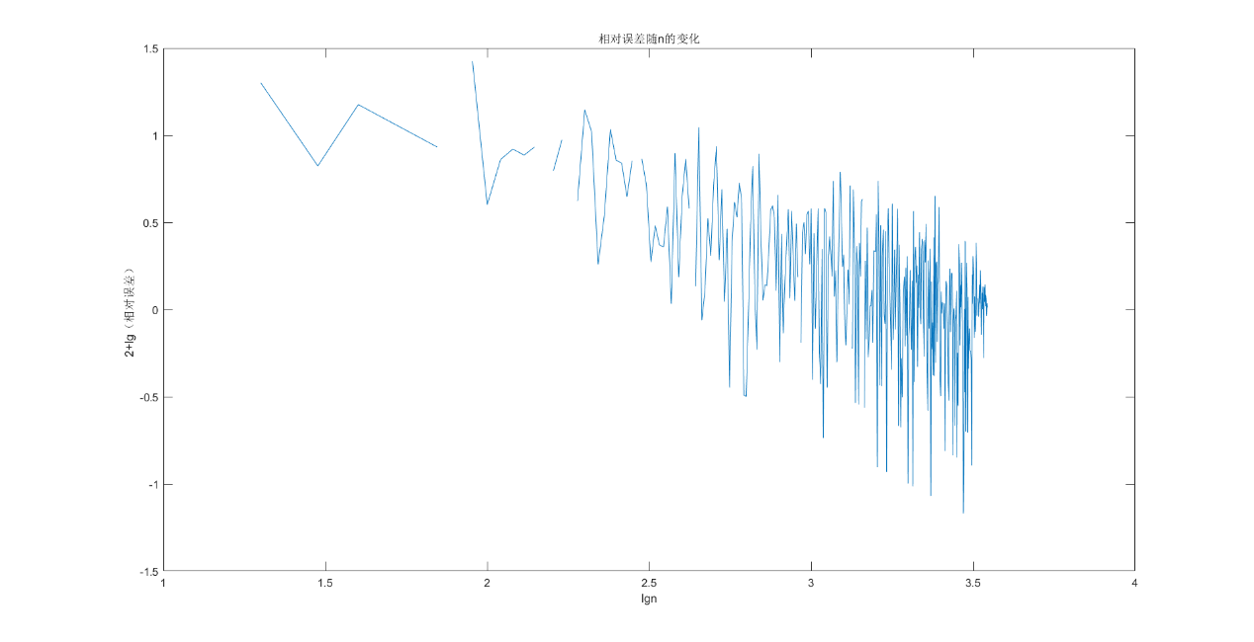

未拟合的n与 $u_{rx}$ 曲线

# 四、备注

所有数据来源于matlab2023b随机生成，

生成种子为当前时间，

生成算法为mt19937ar.

1. 卫淑之、熊德文、皮玲：《大学数学 概率论与数理统计——基于案例分析》，北京，高等教育出版社，2020年，第152页。